

Houbara Standardized Circular Observation protocol (SCO) in North Africa

Writer: Thibault Dieuleveut
Reviewers: Christelle Lucas,
Version: 1
Date: 01/03/2021

Table of content

I. Generalities 3
II. Field sampling design 3
III. Houbara MSCO specifications 4
IV. Operating mode 4

I. Generalities

Standardized circular observation (SCO/MSCO) protocols are based on observation points and designed following standards of distance sampling analyses. The data are collected in a way that allows to extract density or abundance of the targeted species in a given area.

They consist in a set of circular observations (360°) performed to detect the targeted species. They are standardized in the sense that the period, number of observers, observation tools, observation duration and spatial location of observation points are pre-determined.

The key data collected is the distance between observers (observation point) and the groups (or single individuals) observed of the targeted species, as well as the group size.

Few basic assumptions need to be verified for the method to be valid:
- Targeted species distribution is random and independent of observation points;
- Distance are measured accurately;
- Detection at low distance is perfect;
- No induced movement by observers before detection.

II. Field sampling design

The reference observation points are coming from a regular grid (generally 5 km between points). This grid is validated once, and each point can be moved until 300 m away from the theoretical one to provide better visibility. This validated grid will remain the basis for all upcoming surveys and will not be modified anymore. This validated grid is definitely stored in ecology database and and uploaded to GPS for each survey.

In order to get a better area coverage, a second grid of same step can optionally be interposed. In this case, the second grid is surveyed only after the first one is completed, to avoid direct perturbations due to proximity between points.

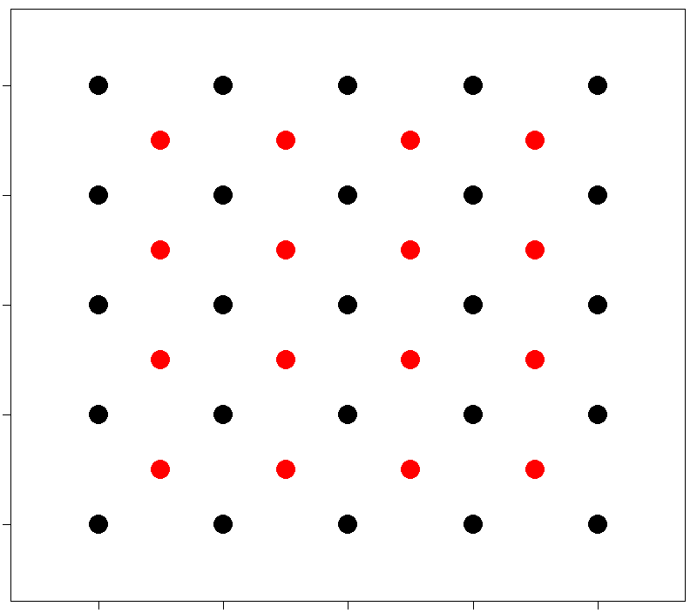
Figure 1. Theoretical example of a grid (black dots), with a second grid interposed (red dots).

One full coverage of one grid corresponds to one session. According to local specifications (for example to reach a sufficient number of observation), several sessions can be performed successively (with small temporal gap between them). In case of use of interposed grid, each grid is used in alternation.

III. Houbara MSCO specifications

Target: All Houbaras
Observation duration: 20 min.
Number of observers: 2.
Tools: 2 observers with binoculars.
Position of observers: One from pick-up bed or step of the car, the other on the ground.
Angle covered by each observer: 360°.
Period in the day: morning (within 3 hours after sunrise) and evening (within 2 hours before sunset).
Period in the year: Post-breeding season.

IV. Operating mode

The observers reach the reference point as close as possible and by driving slowly in order to minimize disturbance in the vicinity of the point.

Before arriving to the point and while driving, any Houbara within 500 m from the observation point will be recorded by a GPS. These Houbaras (seen before realization of circular observation) will be included in the circular observation process and their observation time will be set artificially to the start time of this observation point (or 0 min elapsed). Hence a particular attention should be paid to detect these individuals (for example a very short circular observation with naked eyes while arriving on observation point may help to detect escaping birds).

Arrived on the reference point, one observer takes a GPS point of the real observation point.

The circular observation starts for the defined duration (use of timer if possible). The fieldworkers observe in opposite bearings and turn in the same direction.

In case of sighting of a Houbara, the timer is stopped (if applicable) and the observers:
- share the observation;
- report estimated distance and angle from north (use compass from the roof or away from the car) for a first estimation of the Houbara group location;
- takes landmarks to retrieve the precise location afterwards.

The timer is then restarted (if applicable) and circular observation is proceeded.

After the circular observation completion, the observers reach the different display locations, helped by landmarks previously taken (and/or guided by one observer staying on the observation point and using walkie-talkie) and make a GPS point of each.

If for any reason a location could not be reached, the final data recorded will be the estimated location with no GPS point (estimated distance + angle from north).

